**[](http://www.mossgroup.us/)**­

Bureau of Justice Assistance

First Line Supervisor Training

*Emerging Leaders in Corrections*

Participant Guide

December 2024

# First Line Supervisor Training Emerging Leaders in Corrections

Table of Contents

First Line Supervisor Training Emerging Leaders in Corrections 2

Acknowledgments 3

Course Schedule 4

Course Objectives 4

Participant Guide Organization 4

Participant Introductions 4

Module 1: The Big Picture 5

Module 2: The Basics 8

Module 3: The Skills 17

Module 4: It’s All Connected 32

Additional Resources: 40

## Acknowledgments

This project was supported by Grant No. 2019-RY-BX-K002, awarded by the Bureau of Justice Assistance. The Bureau of Justice Assistance is a component of the Department of Justice's Office of Justice Programs, which also includes the Bureau of Justice Statistics, the National Institute of Justice, the Office of Juvenile Justice and Delinquency Prevention, the Office for Victims of Crime, and the SMART Office. Points of view or opinions in this document are those of the author and do not necessarily represent the official position or policies of the U.S. Department of Justice.

The overall purpose of this training is to support first line supervisors who are newly appointed to supervisorial positions. This curriculum is grounded in research, practitioner experience, and input from supervisors across the nation. TMG would like to thank all who contributed to and supported the development of this curriculum, including the Colorado Department of Corrections, for participating in its pilot.

______________________________________________________________________

Copyright © 2024

The Moss Group

1312 Pennsylvania Avenue, SE

Washington, DC 20003

This training and participant guide is developed by The Moss Group, Inc. (TMG), a Washington, DC-based criminal justice consulting firm. Our philosophy and mission are simple: We are a trusted partner to leaders and their organizations in creating optimal safety and well-being for staff and those persons under their care. We specialize in assisting state, local, federal, and private organizations in developing strategic solutions to often sensitive issues that face correctional administrators. Our customer-focused philosophy ensures we deliver programs, products, and solutions on issues responsive to our customer’s needs.

TMG would like to thank all the participants in this training for your time and thoughtful interaction.

## Course Schedule

This curriculum is designed for correctional professionals who have recently been promoted to supervisor positions in adult correctional centers. Content is also relevant to tenured first line supervisors. This is designed as an in-person two-and-a-half-day training.

* Welcome and Introduction to OJP and BJA
* Module 1: The Big Picture
* Module 2: The Basics
* Module 3: The Skills
* Module 4: It’s All Connected
* Questions and Closing

## Course Objectives

1. Review the big picture of leadership, organizational systems, and the importance of effective supervisors.
2. Develop proficiency for performing the basic functions of a supervisor and transitioning into the role by defining personal acumen through policy alignment, professional boundaries, communication skills, and decision making.
3. Demonstrate effective communication skills as a supervisor through listening, empathy, adaptability, and discretion to oversee change and manage conflict.
4. Apply skills to motivate, coach, and support staff effectively in today’s climate and encourage development for the next class of supervisors.

## Participant Guide Organization

This manual contains information presented during this training course as well as the worksheets associated with individual and group activities. Participants are encouraged to use this resource to follow along through the course. Space is provided for participants to take notes. This guide is yours to keep as reference material throughout your career. At the back of this guide is a list of additional reading material and resources, which you are encouraged to access as you further your supervisory skills.

## Participant Introductions

Write down your responses for the introduction activity.

* What are you most looking forward to as a new supervisor?
* What do you hope to bring to this position?

# Module 1: The Big Picture

**Leadership and Organizational Systems**

* **Dream Team Activity:**Think about a team you’ve been on that was healthy and functioned well.   
    
  What words would you use to describe that team?
* **Healthy Team Characteristics**
  + Trust
  + Clear communication
  + Defined roles and responsibilities
  + Engaged leadership
  + Diversity
  + Conflict
  + Collective goals
* **Mission Statements** 
  + With
    - * Identify goals
      * Establish direction
      * Published commitment
      * Ability to measure success
  + Without
    - * Unclear expectations
      * Dysfunction
      * Competitive environment
      * Chaotic
* **Administrators and Supervisors** 
  + Administrators
    - * Set the vision
      * Influence and inspire
      * Drive change and set the culture
      * Proactive and forward-thinking
  + Supervisors
    - * Implement the vision
      * Drive people to get things done
      * Enact the culture
      * Reactive; short-term focused
* **Continuum of Justice Involvement**

|  |  |  |
| --- | --- | --- |
| **Gavel with solid fillFront** | Jail with solid fill**Middle** | Playbook with solid fill**End** |
| * + Juvenile justice reform   + Alternatives to   incarceration   * + Bail reform   + Policing   + Sentencing   + Prosecutorial reform | * + Education   + Programming   + Vocational opportunities   + Ending solitary   + confinement   + Closing juvenile centers   + Special housing   + Mental health   + Early release | * + Reentry supports   + Transitional housing   + Healthcare   + Employment   + Family Reunification |

* **What other groups or stakeholders interact with corrections?**
* **Three Types of Organizational Systems** 
  + Ones you control
  + Ones you influence
  + Ones you experience
* **Activity: Thinking Within Systems**

This activity is delivered with a handout. Use this space to record your scores for each round, as well as general reflections on the activity.

* + Round 1 Results: __________
  + Round 2 Results:___________
* **Tough Realities for Supervisors** 
  + Supervisors are the key intersection linking line staff and upper management.
    - * Overleveraged
      * Targeted or blamed
      * Unrealistic expectations
* 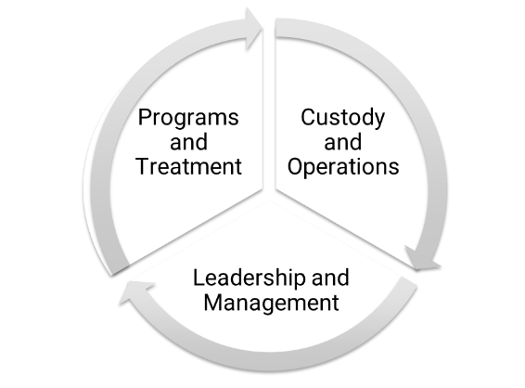**Your Spot in the System**

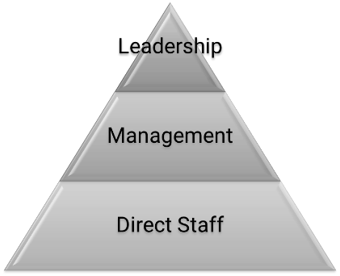

* **Silo Effect**



* **Module 1 Wrap-up**
  + Question 1: Multiple Choice
    - * **Which of the below is NOT a characteristic of a healthy team?**
    1. Trust
    2. Conflict
    3. Mascot
    4. Defined Roles
       - Answer: ___________
  + Question 2: True or False
    - * **Leaders define what to do. Supervisors drive how it’s done.**
      * Answer: ___________

# Module 2: The Basics

**Establishing Your Management Acumen**

* **Activity: Effective and Ineffective Supervisors** 
  + Write down the characteristics associated with each type of supervisor in the space provided.

|  |  |
| --- | --- |
| **Effective Characteristics** | **Ineffective Characteristics** |
|  |  |

* **Who Played it Best?**
* **Supervisor Acumen Styles** 
  + ****Authoritarian: Top-down, power, non-collaborative
  + **A black background with a black square

    Description automatically generated with medium confidence**Bureaucratic: Rules driven, policy, maintaining status quo
  + ****Democratic: Team-driven, open to input, collaborative
  + ****Servant: Putting people first, sharing knowledge, flexible
  + Visionary: Growth-focused, challenging to exceed
* **Supervisor Style Factors**

* **Top 5 Correctional Supervisor Skills**

1. Active listening
2. Critical thinking
3. Monitoring
4. Social perceptiveness
5. Coordination

* **What are some concerns you have as a new supervisor?**
* **Tug of War**

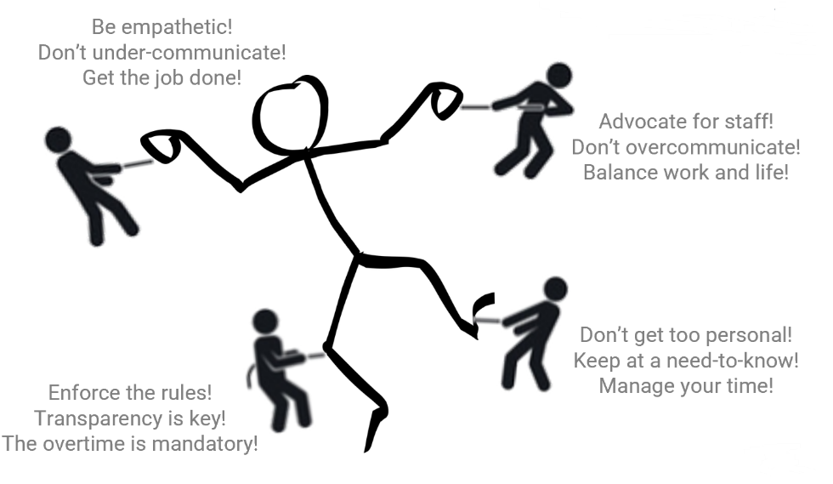

* **Core Competencies**

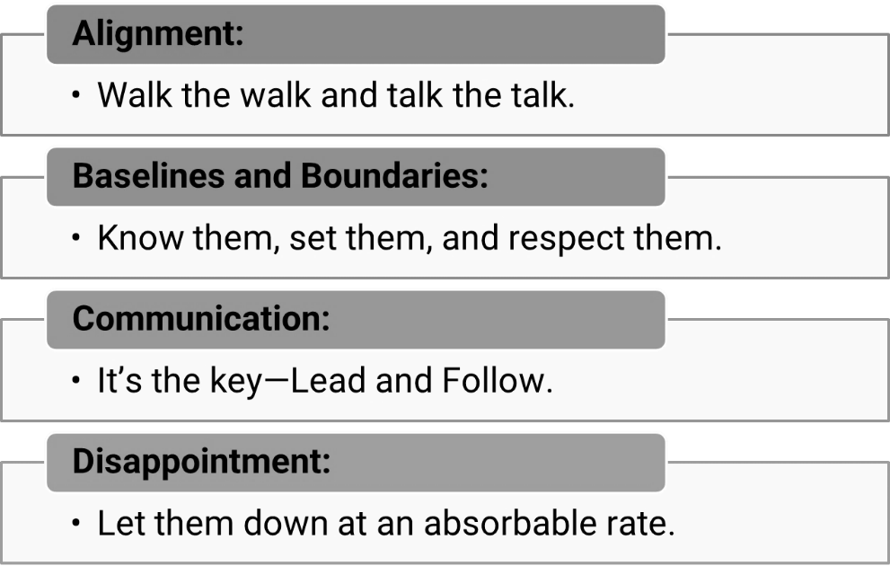

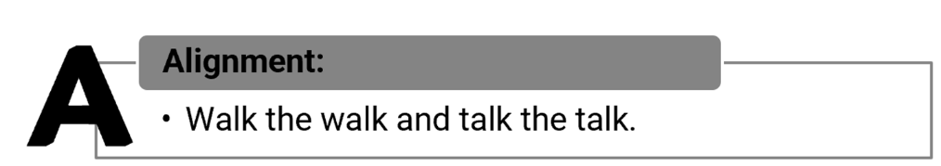

* **A: Alignment: Walk the walk and talk the talk.** 
  + Familiarize yourself with policy and department expectations.
  + Model policy and hold others to the same standard as yourself.
* **Video: Trust and Performance**
* **What does performance and trust look like?**
* **It Takes Time** 
  + Intentional and built over time
  + Result of your actions and character
  + Rooted in consistency and equitability
  + Cornerstone of culture

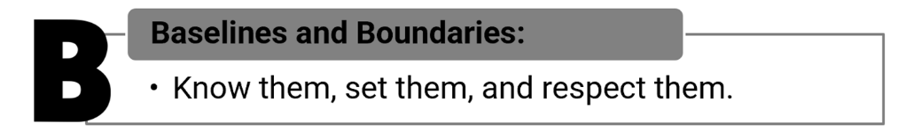

* **Baselines and Boundaries: Know them, set them, and respect them.** 
  + What are baselines?
    - * Involve our most basic attitudes, behaviors, and tendencies
      * Formed by our genetic makeup and unique experiences
      * Shape and influence how we perceive, interpret, and respond
  + What are boundaries?
    - * Legal, ethical, and organizational framework
      * Guidelines, expectations, and rules to protect us all
      * Defines limits to prevent blurred or crossed lines
      * Separation of work and personal life
* **What are the benefits of having professional boundaries?**
* **What are the risks of not having professional boundaries?**
* **What types of attitudes or behaviors should you be looking out for? From yourself? Fellow supervisors? Your staff?**
* **Red Flag Attitudes and Behaviors** 
  + Inconsistent enforcement of rules and policy
  + Distancing from staff – more aligned with the population
  + Doing work meant for someone else
  + Excessive time spent without reason
  + Not using vacation time
* **What concerns, if any, do you have about redefining your professional boundaries?**
* **Boundaries with Former Peers** 
  + Address the elephant in the room
  + Reset the dynamic
  + Ask for discretion and patience
* **Professional Boundaries Small Group Activity**

As a group, answer the following questions related to professional boundaries.

Be prepared to share your answers with the class.

Fill in your team’s assigned concern: ____________________________________

1. Name two solutions for addressing your assigned concern.
2. Identify three ways you can support or encourage boundaries.

* **Strategies to Support Safety** 
  + Get to know yourself
  + Get to know your staff
  + Recognize triggers
  + Engage healthy rechargers
  + Recognize red flags
  + Safe reporting culture
* **Model the Expectation** 
  + Redefine your boundaries based on new acumen styles required as a supervisor
  + Value self-wellness
  + Manage workload – delegation and fairness
  + Model routine maintenance

* **Communication: It’s the Key – Lead and Follow** 
  + How might communication skills look different as a supervisor?
  + What communication skills do you see or hear about supervisors struggling with?
* **Communication Flow**

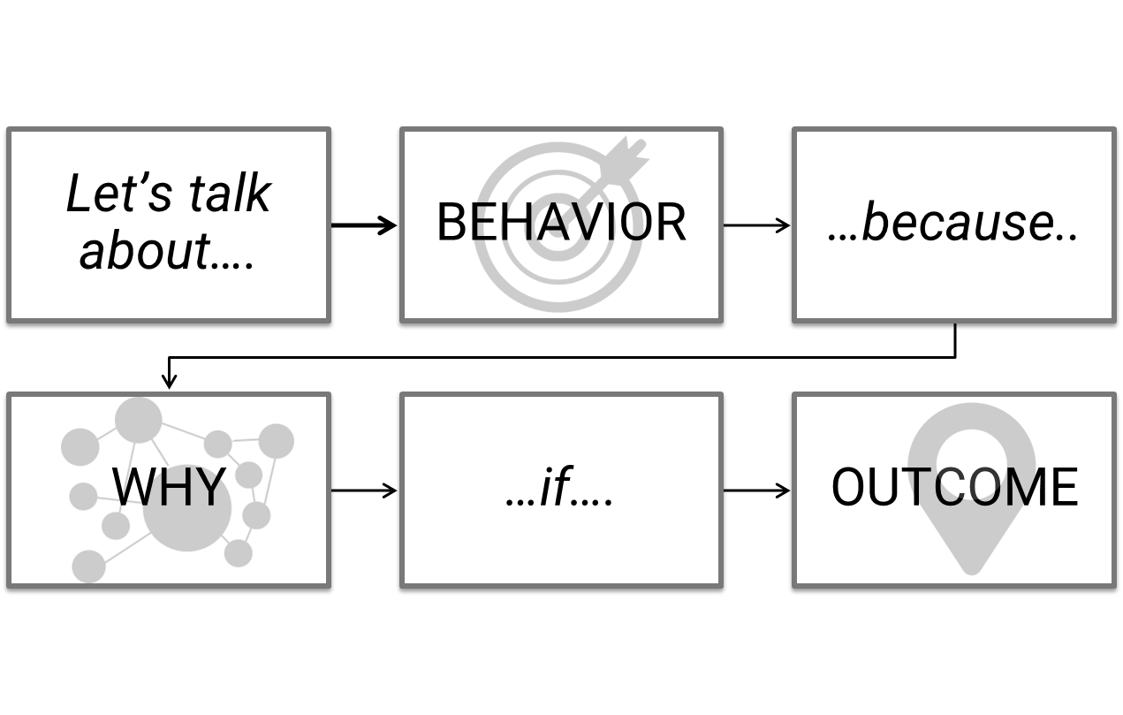



* **Differing Viewpoints Activity** 
  + - 1. Circle the role you will play in this activity.

Side A Side B Observer

* + - 1. Side A and B, review your position and prepare your argument.
      2. Observers begin the activity by asking each side to present their argument. Select one side to begin. Take notes as needed. Listen to facilitator instructions.
      3. Observers record and report on the outcome.

1. Summarize the arguments presented.
2. What were the main points each side was making –what did they value?



***“Leadership is about disappointing people at the rate they can absorb.”***

-Marty Linsky

Professor, Harvard University Kennedy School of Government

Cambridge Leadership Associates Co-founder

* **A Supervisor’s Truth**

“*If you’re a new manager, you probably feel a burning desire to be liked and accepted by your team…You want to win people’s approval, keep them happy, and demonstrate all the desirable attributes of a great boss.  
  
Even so, as the person in charge, almost everything you do will have the potential to trigger conflict…We constantly risk not being loved by the masses.”*-Martin G. Moore

* **How can you manage disappointment at an absorbable rate?**
* **Strategies for Disappointment** 
  + If you make a mistake, apologize.
  + Strive for a balance between good and bad news.
  + Acknowledge that “fair” is often subjective.
  + Evaluate expectations.
  + Limit the spread.
  + Promote staff wellness and rechargers.
* **Module Two Wrap-up**

# Module 3: The Skills

**Strategies and Techniques Used by Effective Supervisors**

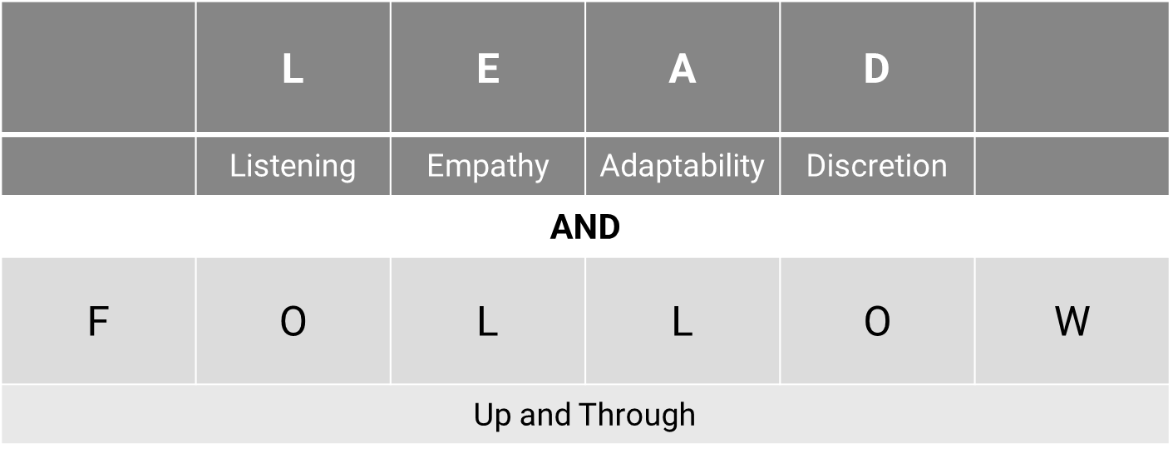

* **Active Listening**
  + Hearing
    - * Accidental
      * Involuntary
      * Effortless
* **Toss Game Takeaways**
  + Listening
    - * Focused
      * Voluntary
      * Intentional
* **How do you know when someone is actively listening to you?**
* **Active Listening Techniques** 
  + Ask questions, especially open-ended questions.
  + Paraphrase back what you’ve heard in your own words.
  + Use encouragers.
  + Replace judgment with curiosity.
  + Don’t think about how you might respond.
  + Focus on the person speaking – nod and make eye contact
* **How else can you be an effective listener?**

*******“I remind myself every morning: ‘Nothing I say this day will teach me anything. So, if I’m going to learn, I must do it by listening’.”*Larry King

* **Effective Listening** 
  + Read the room
  + Know when to stop or start talking
  + Social cues
  + Consider the context
  + Group dynamics
  + Listening ratio
* **Message Detractors and Enhancers** 
  + Seven percent spoken words, 38 percent tone of voice, and 55 percent body language
* **Tone Management: De-escalation** 
  + **Notice** your own body language and tone of voice. Model the calm response you want from the other person.
  + **Offer** reflective comments that show you are listening to what they say and how they feel.
  + **Wait** for the other person to explain their position and release the emotion (within reason) before responding with solutions
* **Addressing ToneA white rectangular sign with black text

  Description automatically generated**
* **Tone Scenario Activity Takeaways**
* **Body Language and Nonverbals**
  + Posture
  + Eye contact
  + Hand gestures
  + Movement
  + Facial expression
* **Nonverbals Activity Takeaways**
* **Empathy**
* **What Empathy is Not**
  + Problem solving
  + Weakness
  + Agreement
  + Sympathy
* **Gaslighting**
* **It’s All About Perspective**

* **Intent vs. Impact**
* **Listening for What Isn’t Said** 
  + Listen and observe for the underlying issue or emotion.
  + Trust your gut – if there’s more to it, ask questions.
  + Frequent stops or redirects to avoid emotion.
  + Repeating bland phrases – know what I mean?” or “I don’t know.”
* **Empathy Scenario Practice Takeaways**
* **Role Play Activity**

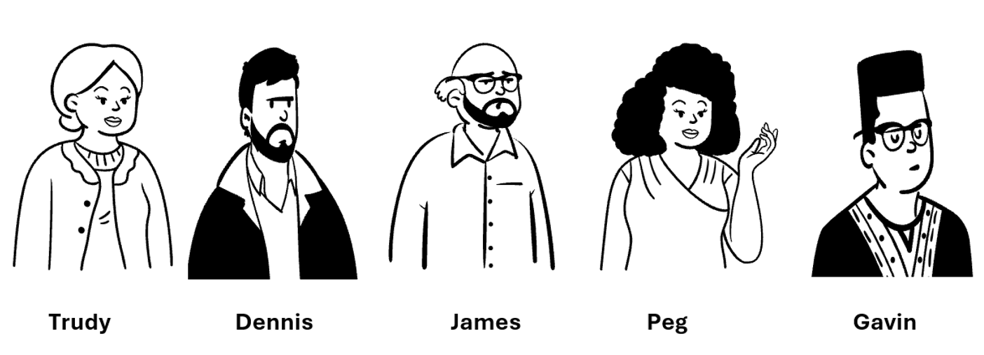

**Role Play Activity 1: Tell Me About Yourself…**

**Observer Preparation**

**Instructions:**

1. **Prepare for the observer role.** Review this observation form. Consult this handbook to refresh your knowledge of key concepts.
2. **Observe the role play.** Fill in the observation form as the interaction continues.
3. **Lead a group debrief.** Share your thoughts on the interaction with the staff member and supervisor.

**Observation Form:**

1. What was the overall goal of the interaction?
   1. Was it achieved? Why or why not?
   2. What did each person value?
2. How did the supervisor reflect the following:

* Alignment with policy
* Baselines and boundaries
* Communication Skills
* Disappointment
* Listening
* Empathy
* Any additional feedback or advice?
* **Adaptability**
* **What does adaptability look like as a supervisor?**

*“It is not the strongest of the species that survives, nor the most intelligent that survives. It is the one that is most adaptable to change.”*

*-Charles Darwin*

* **Adapt, Migrate, or Go Extinct**
* **Building Resiliency** 
  + Resistance
    - * Natural
      * Opportunity for improvement
  + Resilience
    - * Learned
      * Self-preservation
  + Recovery
    - * Recharge
      * Rest

Fill in the blank: Change is ___________

* **Types of Change**
* Predictable
* Planned
* Welcomed
* Unwelcomed
* Unexpected
* **How have you seen people react to change at work?**
* **External and Internal Forces of Change**

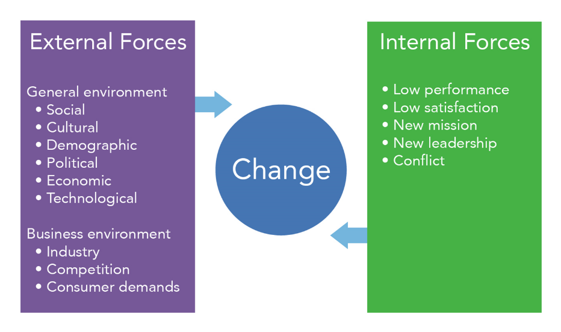

* **McDonald’s Case Study**
* The first McDonald’s opened in 1940 in San Bernardino, California, by Richard and Maurice McDonald.
* Opened as a full-service carhop barbeque joint using real plates and silverware with over 40 barbecue items.
* Soon, they realized that 80 percent of their sales were hamburgers.
* In 1948, it closed for three months and rebranded as a hamburger self-service restaurant.
* Fired 20 employees, switched to single-use containers and cups, and simplified to nine items.
* Used a 12-person crew who specialized in specific tasks.
* In 1954, Ray Kroc, a milkshake mixer salesman, visited McDonalds that was using eight of the mixers.
* Kroc was intrigued by the business model and was hired in 1955 as the franchise agent.
* Kroc bought the company from the brothers in 1961 for $2.7 million after years of arguments.
* In 1955, there were nine stores; by 1963, there were 500 stores.
* Today, there are over 36,000 franchises in over 100 countries.
* **McDonald’s Case Study Worksheet**

**McDonald’s Case Study Instructions**

With your small group, discuss the assigned topic and answer the questions below.

**Circle Your Assigned Topic:**

* Advertising
* Technology
* Community
* Competition
* Labor
* Cultural influence
* Menu

**Case Study Questions:**

1. How have you seen or experienced McDonald’s addressing this topic? What changes have you seen over the years?
2. Why would McDonald’s address this topic? What is the objective?
3. How might it continue to change?
4. If you were the store supervisor, what resistance would you expect from staff? From customers?
5. How would you message these changes to your staff? To the customers?

* **Mission Statements**
* …to be our customers’ favorite place and way to eat and drink.
* …to be our customer’s first choice when it comes to top-quality products, outstanding service, cleanliness, and great value for money.
* …to feed and foster communities.
* …to make delicious, feel-good moments easy for everyone.
* **How can understanding drivers of change support you as a supervisor?**
* **Managing Change**
* Firm, fair, and consistent
* Help slow or prevent burnout
* Anticipate needs and resistance
* Support resilience and recovery time
* **Individual Activity**

Your Captain informed you the facility is going to be installing new cameras and issuing body-worn cameras to staff. The cameras will be installed in the coming months, and the body-worn cameras will arrive in the coming weeks. All staff will be required to wear them during their full shift. You’ve been instructed to make the announcement at the shift briefing.

* What questions would you have for the captain?
* What would you take into consideration?
* What, if any, resistance do you anticipate from staff?
* **Discretion**
* **What do you think about when you hear the term discretion?**
* **Supervisor Discretion**
* Time management
* Problem solving
* Confidentiality
* Trust and morale
* Staff interactions
* Decision making
* Authority
* Expectation setting
* **Targeted Focus for Discretion**

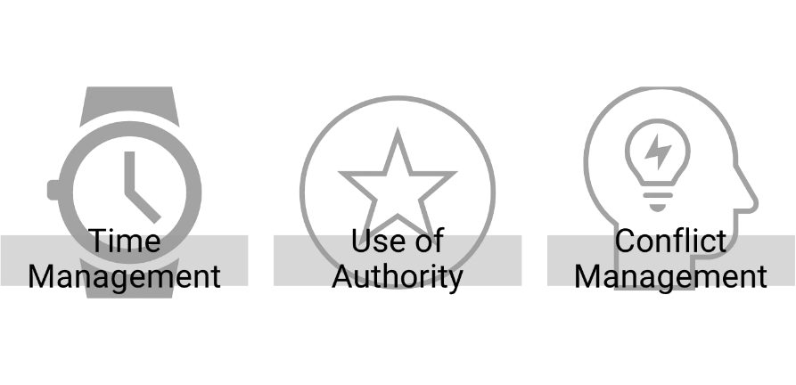

* **Time Management**
* Be realistic
* Do routine audits
* Use scheduling aids
* Delegate tasks
* Honor breaks
* **The Eisenhower Matrix Activity**

**Activity Instructions:** Place the corresponding letter into the quadrant that reflects how you would prioritize each task.

1. The gate officer tells you there was a fight last night in your unit involving staff injuries.
2. An email comes in requesting your presence at a disciplinary hearing for an infraction you submitted.
3. You are called over the radio to report to the officer station to escort a visitor.
4. Another officer asks you what you’re bringing for the retirement picnic this weekend.
5. An officer reports to you that a shank has been found in the dayroom.
6. There’s a report on your desk that an incarcerated individual reported being sexually assaulted in the shower.
7. There’s a message from the local police department that a staff member was arrested over the weekend.
8. Your Captain asks to see you in their office.

* **Authority vs. Power to Influence**
* **Types of Power**
* Expertise: What you know
* Network: Who you know
* Rewards: What you can offer
* Fear: What you can take away
* Information and Resources: What you can withhold or leverage
* Charisma: How much you are liked
* Longevity: How long you’ve been around
* **Promoting Your Influence**
* Get feedback
* Reflect and apologize
* Delegate
* Acknowledge other’s gifts
* Advocate and encourage
* Promote work-life balance
* **Conflict Management Styles**

* **Conflict Considerations**
* Time, place, and reason
* Responsibility and goal
* Demeanor and attitude
* Past and preparation
* Expectations and exit strategy
* **Addressing Staff Behavior**

* **Role Play Activity 2: Do You Have A Minute…**

**Role Play Activity 2: Do You Have A Minute…**

**Observer Preparation**

**Instructions:**

1. **Prepare for the observer role.** Review this observation form. Consult this handbook to refresh your knowledge of key concepts.
2. **Observe the role play.** Fill in the observation form as the interaction continues.
3. **Lead a group debrief.** Share your thoughts on the interaction with the staff member and supervisor.

**Observation Form:**

1. What was the overall goal of the interaction?
   1. Was it achieved? Why or why not?
   2. What did each person value?
2. How did the supervisor reflect the following:

* Alignment with policy
* Baselines and boundaries
* Communication Skills
* Disappointment
* Listening
* Empathy
* Adaptability
* Discretion

1. Any additional feedback or advice?

**Role Play Activity 3: We Need to Talk…**

**Observer Preparation**

**Instructions:**

1. **Prepare for the observer role.** Review this observation form. Consult this handbook to refresh your knowledge of key concepts.
2. **Observe the role play.** Fill in the observation form as the interaction continues.
3. **Lead a group debrief.** Share your thoughts on the interaction with the staff member and supervisor.

**Observation Form:**

1. What was the overall goal of the interaction?
   1. Was it achieved? Why or why not?
   2. What did each person value?
2. How did the supervisor reflect the following:

* Alignment with policy
* Baselines and boundaries
* Communication Skills
* Disappointment
* Listening
* Empathy
* Adaptability
* Discretion

1. Any additional feedback or advice?

* **Module 3 Wrap-up**
* What are the LEAD skills and techniques?
  + - * L
      * E
      * A
      * D

# Module 4: It’s All Connected

**Cultivating Growth and Employee Engagement**

* **Follow-up and Follow Through**

Follow-up is…

…creating further action.

* Feedback
* Feedforward
* Performance reviews
* Coaching

Follow Through is…

…bringing to a conclusion.

* Creating closure
* Celebrating wins
* Keeping promises
* Showing appreciation
* **How do follow-up and follow-through impact staff?**
* **Effects of Follow-up and Follow-through**

Engagement Growth Retention

* **U.S. Employee Engagement Trend**

* **Supervising in Today’s Climate**
* Post-COVID era – changes in population
* Law enforcement accountability movements
* Use of technology – remote work limits to collaboration
* Staffing shortages
* Employee engagement and generational differences
* **Employee Engagement**
* In 2016, 74 percent of employees were willing to support organizational changes, but dropped to 38 percent in 2022.
* Highly engaged workplaces saw 41 percent lower absenteeism.
* Thirty percent of new hires leave within 90 days because the role didn’t meet expectations (43%), a specific incident (34%), and culture (32%).
* **Correction Worker Shortage**

* **Employee Turnover**
* Forty percent of workers report high employee turnover at their organization over the past year
* Fifty-eight percent of frontline/essential workers report working more in the past year because of high employee turnover (versus 28 percent of non-frontline workers)
* This has led to an increase in stress levels and feelings of burnout in 78 percent of workers
* **Potential Signs of Burnout**
* Exhaustion
* Loss of enthusiasm for work – reduced performance
* Worry or anxiety
* Changes to sleep and/or diet
* Irritability and mood swings
* Physical symptoms: headache, stomach issues, frequent illness
* **Burnout Indicators**

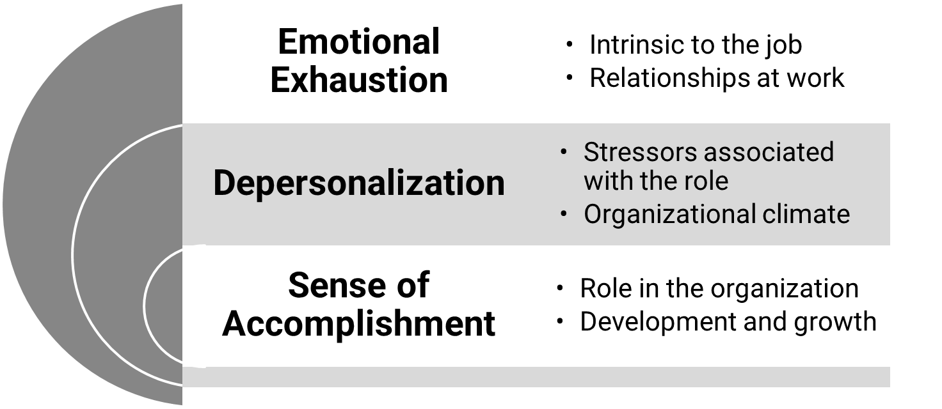

* **How can you help support staff engagement?**
* **Opportunities to Engage Staff**
* Performance reviews
* On-the-job training
* Shift briefings
* Coaching
* Feedback and feedforward
* **What has your experience been with performance reviews?**
* **Feedback**
* Focused on the past
* Requires knowledge of what happened
* Most often used to address what went wrong
* Often associated with judgment
* Effective for identifying behaviors to discontinue
* **Limits of Feedback on Performance Reviews**
* Timing
* Limited data or interaction
* Tied to salary and wages
* Feel too formal and one-sided
* Influenced by past experiences
* **Feedback and Feedforward**

Feedback

* Focused on the past
* Requires knowledge of what happened
* Most often used to address what went wrong
* Often associated with judgment
* Effective for identifying behaviors to discontinue

Feedforward

* Focused on the future
* Seeks to understand goals and desired skills
* Used to emphasize what is possible
* Often associated with encouragement
* Effective for identifying behaviors to grow
* **Encouragement at Work**

* **Collaborative Coaching**

“Coaching requires managers to transition from the traditional role of controlling and monitoring employee performance to a more consultative role. Coaching is a means for developing a partnership between the manager and employee that creates a shared understanding about what needs to be achieved and how it is to be achieved.”

Alyce Johnson

MIT Human Resources

* Coaching is…
  + - * Motivating
      * Clarity
      * Performance improving
      * Empowering
      * Confidence building
* Coaching is not…
  + - * Mentoring
      * Therapy
      * Fixing
      * Precluding accountability
      * Progressive discipline

**Role Play Activity 4: What’s Next for You…**

**Observer Preparation**

**Instructions:**

1. **Prepare for the observer role.** Review this observation form. Consult this handbook to refresh your knowledge of key concepts.
2. **Observe the role play.** Fill in the observation form as the interaction continues.
3. **Lead a group debrief.** Share your thoughts on the interaction with the staff member and supervisor.

**Observation Form:**

1. What was the overall goal of the interaction?
   1. Was it achieved? Why or why not?
   2. What did each person value?
2. How did the supervisor reflect the following:

* Alignment with policy
* Baselines and boundaries
* Communication Skills
* Disappointment
* Feedback
* Listening
* Empathy
* Adaptability
* Discretion
* Feedforward

1. Any additional feedback or advice?

* **Module 4 Wrap-up** 
  + Question 1: Multiple Choice
    - * **Which of the following is NOT an effect of follow-up and follow-through?**

1. Retention
2. Technology
3. Engagement
4. Growth
   * + - Answer: ___________
   * Question 2: True or False
     + - **Coaching is most effective when it is continuous.**
       - Answer: ___________

* **Takeaway Activity**

Write down the first two or three things you will do to prepare for your next shift because of this training.

1.

2.

3.

Thank you for your participation!

# Additional Resources:

**Slide 7:**

Sousa, Maria José, Dias Ivo, Moço Isabel, Saldanha Ana, and Caracol Carla. "Project Managers Perceptions about more Effective Leadership Styles." *Journal of International Business Research and Marketing* 2, no.3 (2017): 7-13.

**Slide 9:**

Panel®, Expert. 2020. “Council Post: 14 Characteristics of High-Performing Teams.” Forbes. September 16, 2020. Article available at <https://www.forbes.com/sites/forbeshumanresourcescouncil/2020/09/16/14-characteristics-of-high-performing-teams/>.

**Slide 16:**

Wood, D. September 2019*. Ending This Place of Torment: A Framework for Transforming the Criminal Justice Continuum*. The Aspen Institute Forum for Community Solutions. Article available at [CJRI_Continuum_Report.pdf](https://www.aspeninstitute.org/wp-content/uploads/2020/06/CJRI_Continuum_Report.pdf).

**Slide 20:**

Tyler, Justin. 2020. “The Most Hated: So, You Thought Your Job Was Tough? Try Being Middle Management.” Medium. November 6, 2020. Article available at <https://mercercountyworks.medium.com/the-most-hated-so-you-thought-your-job-was-tough-try-being-middle-management-b8c6f45c8835>.

**Slide 30:**

OwlGuru. January 12, 2021. *How To Become a Supervisor of Correctional Officer*. Screen Shot taken from: How to Become a Supervisor of Correctional Officer (A Step by Step Guide) (owlguru.com).

**Slide 50:**

“Leadership Is about Disappointing People at the Rate They Can Absorb.” 2020. Kristen Ziman. November 21, 2020. Article available at <https://kristenziman.com/leadership-is-about-disappointing-people-at-the-rate-they-can-absorb/>.

**Slide 53:**

Moore, Martin G. 2021. “You’re a Leader Now. Not Everyone is Going to Like You.” *Harvard Business Review*. September 16, 2021. Article available at <https://hbr.org/2021/09/youre-a-leader-now-not-everyone-is-going-to-like-you>..

**Slide 62:**

King, Larry. “I remind myself every morning: ‘Nothing I say this day will teach me anything. So, if I’m going to learn, I must do it by listening’.” *Newsweek*. Article available at <https://www.newsweek.com/best-quotes-larry-king-i-never-learned-anything-while-i-was-talking-1563928>.

**Slide 88:**

Anderson, D., and Anderson, L. A. 2002. *Beyond Change Management: Advanced Strategies for Today’s Transformational Leaders*. San Francisco, CA: John Wiley & Sons.

**Slide 89:**

[What were the drivers of change?](https://commons.wikimedia.org/wiki/File:McDonald's_SVG_logo.svg)

[How McDonald's Beat Its Early Competition and Became an Icon of Fast Food | HISTORY](https://www.history.com/news/how-mcdonalds-became-fast-food-giant)

**Slide 91:**

[McDonald's History Timeline at a Glance (businessinsider.com)](https://www.businessinsider.com/mcdonalds-history-timeline-2016-10)

**Slide 92:**

Anderson, D. and Anderson, L. A. (2002) Beyond Change Management: Advanced Strategies for Today’s Transformational Leaders. San Francisco, CA: John Wiley & Sons.

Naghibi, M. A. and Baban, H. (2011) ‘Strategic change management: The challenges faced by organizations.

**Slide 94:**

[2022–2023 Our Purpose & Impact Progress Summary McDonald’s Corporation (mcdonalds.com)](https://corporate.mcdonalds.com/content/dam/sites/corp/nfl/pdf/McDonalds_PurposeImpact_ProgressSummary_2022_2023.pdf)

**Slide 96:**

American Psychological Association (2018). *The road to resilience*. Retrieved from http://www.apa.org/helpcenter/road-resilience.aspx

Leiter, M. P., & Maslach, C. (2016). Latent burnout profiles: A new approach to understanding the burnout experience. *Burnout Research, 3*, 89-100. Article available at [www.doi.org/10.1016/j.burn.2016.09.001](http://www.doi.org/10.1016/j.burn.2016.09.001).

 Maslach, C., Schaufeli, W. B., & Leiter, M. P. (2001). Job burnout. *Annual Review of Psychology, 52,*397-422.

**Slide 102:**

Scism, R. (November 21, 2022) 5 Tips for Effective Time Management in Public Safety; Stress Management in Public Safety: The Supervisor’s Role. Article avaliable [at](https://www.lexipol.com/resources/blog/5-tips-for-effective-time-management-in-public-safety/) [Time Management for Public Safety Professionals – Lexipol](https://www.lexipol.com/resources/blog/5-tips-for-effective-time-management-in-public-safety/).

**Slide 105:**

M. Kovach,.The Journal of Values-Based Leadership. Volume 13 Issue 2 Summer/Fall 2020. Leader Influence: A Research Review of French & Raven’s (1959) Power Dynamics. Article available at <https://scholar.valpo.edu/cgi/viewcontent.cgi?article=1312&context=jvbl>.

M.Mantell, 2024. Science of People. Power vs. Authority (And Why it Matters in The Workplace). Article available at [Power vs. Authority (And Why it Matters in The Workplace) (scienceofpeople.com)](https://www.scienceofpeople.com/power-vs-authority/).

**Slide 106:**

M.Mantell, 2024. Science of People. Power vs. Authority (And Why it Matters in The Workplace).

**Slide 119:**

Rina Koshkina, Mar 3, 2020, Forbes Coaches Council, The All-Purpose Power Of Follow-Up And Follow-Through In The Recipe For Success, [The All-Purpose Power Of Follow-Up And Follow-Through In The Recipe For Success (forbes.com)](https://www.forbes.com/sites/forbescoachescouncil/2020/03/03/the-all-purpose-power-of-follow-up-and-follow-through-in-the-recipe-for-success/?sh=5e29e6fd5124)

**Slide 122:**

[INDICATORS](https://www.gallup.com/394169/global-indicators.aspx): Employee Engagement: [Global Indicator: Employee Engagement - Gallup](https://www.gallup.com/394373/indicator-employee-engagement.aspx),

**Slide 124:**

[Top 5 HR Trends and Priorities For 2024 | Gartner](https://www.gartner.com/en/human-resources/trends/top-priorities-for-hr-leaders?utm_medium=press-release&utm_campaign=RM_GB_2022_HRL_NPP_PR1_TOPHRPRTY23&utm_term=ebook)—Gartner Workforce Change Survey, 2016 and 2022.

Harter, J. Employee Engagement vs. Employee Satisfaction and Organizational Culture. Gallup. Updated August 13, 2022.

[2018_Job_Seeker_Nation_Study.pdf (jobvite.com)](https://www.jobvite.com/wp-content/uploads/2018/04/2018_Job_Seeker_Nation_Study.pdf); Harvard Business Review; Forbes.

**Slide 125:**

Annual Survey of Public Employment & Payroll, the Census Bureau, [Data Reveals Prison Crisis: More Prisoners, Fewer Correctional Officers | The Marshall Project](https://www.themarshallproject.org/2024/01/10/prison-correctional-officer-shortage-overtime-data), The Marshall Project. January 10, 2024; New Data Shows How Dire the Prison Staffing Shortage Really Is. Available at: www.themarshallproject.org/2024/01/10/prison-correctional-officer-shortage-overtime-data.

**Slide 126:**

2022 Job Seeker Nation Report Dynamic Motivations of Modern Workers. Available at: web.jobvite.com/rs/328-BQS-080/images/2022-12-2022JobSeekerNationReport.pdf.

**Slide 127:**

Mayo Clinic, Job burnout: How to spot it and take action. *Healthy Lifestyle, Adult Health. Available at:* <https://www.mayoclinic.org/healthy-lifestyle/adult-health/in-depth/burnout/art-20046642>

Cleveland Clinic. February 1. 2022. What Is Burnout? Available at: <https://health.clevelandclinic.org/signs-of-burnout>

**Slide 128:**

Forman-Dolan J, Caggiano C, Anillo I, Kennedy TD. Burnout among Professionals Working in Corrections: A Two Stage Review. *International Journal of Environmental Research and Public Health*. 2022; 19(16):9954. <https://doi.org/10.3390/ijerph19169954>

**Slide 136:**

Most U.S. Employees Lack Someone at Work Who Encourages Their Development (Gallop), [INDICATORS](https://www.gallup.com/394169/global-indicators.aspx): Employee Engagement: [Global Indicator: Employee Engagement - Gallup](https://www.gallup.com/394373/indicator-employee-engagement.aspx),

**Slide 137:**

Alyce Johnson, MIT Human Resources, [What is Coaching? | MIT Human Resources](https://hr.mit.edu/learning-topics/leading/articles/what-is-coaching), [What is Coaching? | https://hr.mit.edu/learning-topics/leading/articles/what-is-coaching#:~:text=Coaching%20requires%20managers%20to%20transition%20from%20the%20traditional,achieved%20and%20how%20it%20is%20to%20be%20achieved.MIT Human Resources](https://hr.mit.edu/learning-topics/leading/articles/what-is-coaching)

**Slide 138:**

*Forbes,* The '8 Great' Accountability Skills for Business Success.